**Narayan Behera MCA sem-1**

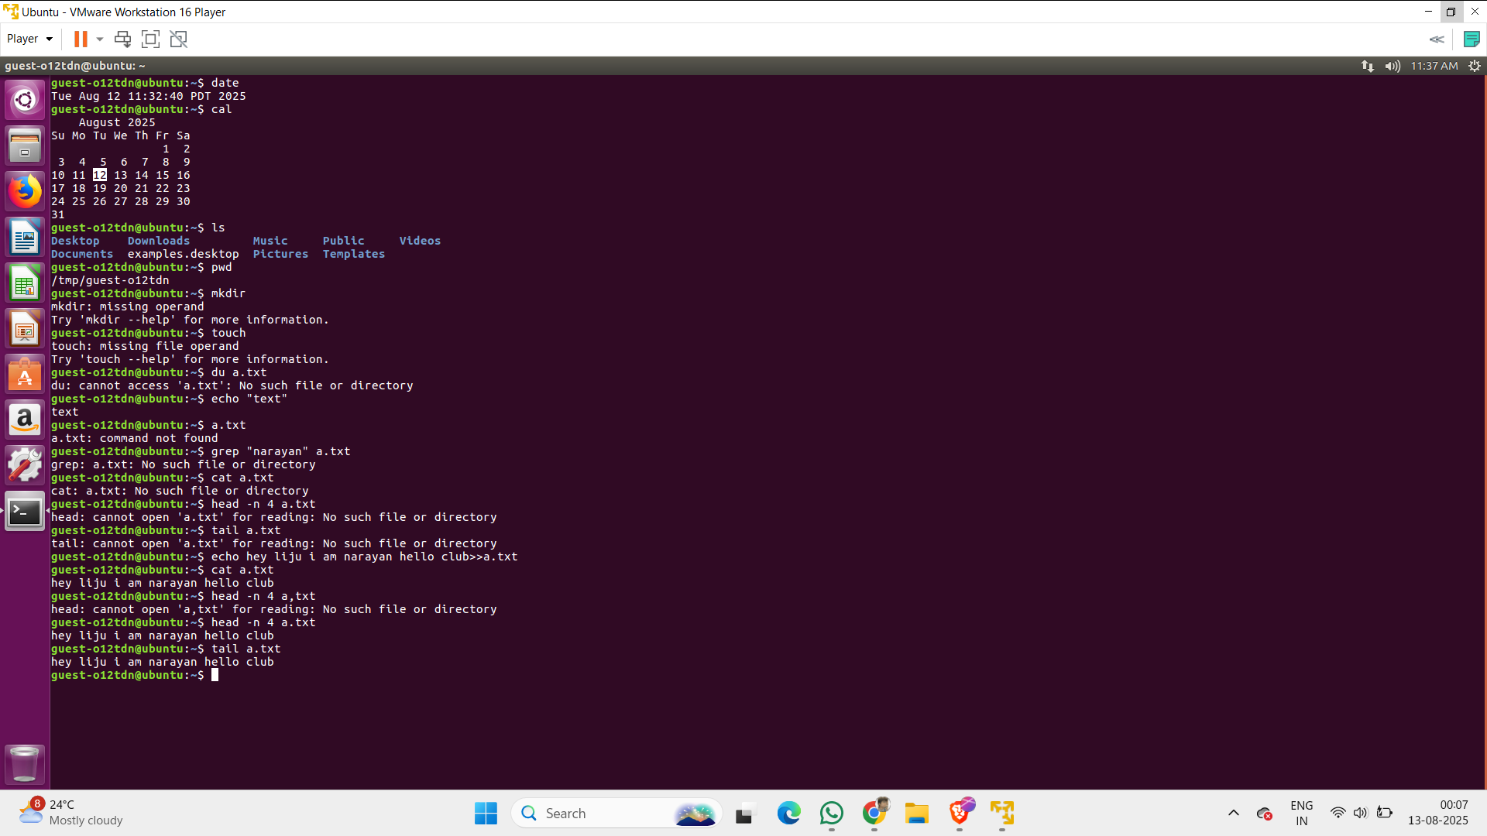

1. **date → Shows the current date and time.**
2. **cal → Displays the calendar of the current month.**
3. **ls → Lists all files and folders in the current directory.**
4. **pwd → Prints the current working directory path.**
5. **mkdir → Creates a new folder (directory).**
   * **In your case, it showed “missing operand” because you didn’t give a folder name.**
6. **touch → Creates an empty file or updates the file’s last modified time.**
   * **You got “missing file operand” because you didn’t give a filename.**
7. **du a.txt → Shows the disk usage (file size) of a.txt.**
   * **It failed at first because the file didn’t exist.**
8. **echo "text" → Prints the text to the terminal.**
9. **a.txt → You typed the filename directly, but that’s not a valid command.**
10. **grep "narayan" a.txt → Searches for the word “narayan” inside a.txt.**
11. **cat a.txt → Displays the full content of a.txt.**
12. **head -n 4 a.txt → Shows the first 4 lines of a.txt.**
13. **tail a.txt → Shows the last 10 lines of a.txt (default).**
14. **echo hey lijju i am narayan hello club >> a.txt → Appends the text to a.txt (adds at the end).**